2026 May Day MCM
Problem A. Coal Mine Tunnel Support
Coal mine tunnels serve as critical pathways for efficient and safe production in underground mines, and surrounding rock support is essential for preventing roof collapse and ensuring the normal operation of equipment. Among various support technologies, rock bolt support plays an irreplaceable role in tunnel support due to its advantages of convenient construction, strong adaptability, and cost-effectiveness, and has also been widely applied in geotechnical engineering, civil air defense engineering, bridge and tunnel construction, urban subway systems, and other fields.
The support principle of rock bolts involves applying a pre-tightening torque by tightening the nut at the tail end of the bolt. This torque is transmitted through the threads and converted into an axial preload along the bolt body, thereby transforming the surrounding rock from a biaxial stress state into a triaxial stress state and achieving active support (as shown in Figure 1). In engineering practice, it is generally believed that the higher the pre-tightening torque, the greater the preload and the better the support effect. However, the conversion relationship between pre-tightening torque and preload is not a simple linear one; it is also affected by various factors such as thread clearance, contact surface conditions, and surrounding rock properties. Therefore, in-depth investigation of the conversion mechanism between pre-tightening torque and preload is of great significance for achieving scientifically sound tunnel support.
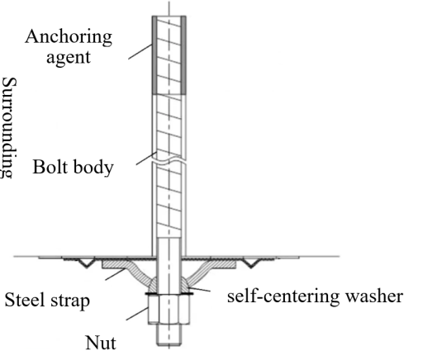 | 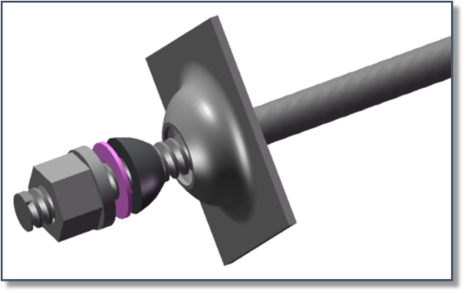
(a) Rock bolt support cross-section | (b) Rock bolt support component assembly
Figure 1. Schematic diagram of rock bolt support
Although the Technical Specification for Prestressed Anchor Construction in Coal Mines stipulates that the initial pre-tightening torque should be no less than 150 N·m, in practice, there are often cases of inefficient support where the pre-tightening torque meets the requirement but the preload is insufficient; alternatively, in soft coal bodies, blindly pursuing high torque may cause the bearing plate and nut to penetrate into the coal body, compromising the support effect (as shown in Figure 2). How to accurately establish a conversion model between pre-tightening torque and preload, reveal the influence patterns under different interface conditions, and thereby determine the critical pre-tightening torque to obtain optimal construction parameters is a key scientific issue for achieving intelligent and green tunnel support.
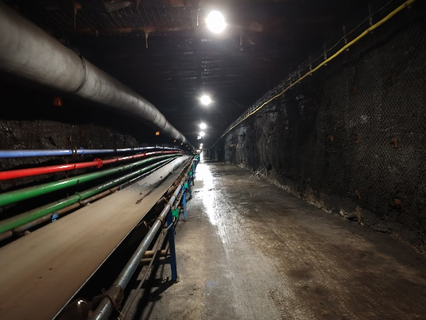 | 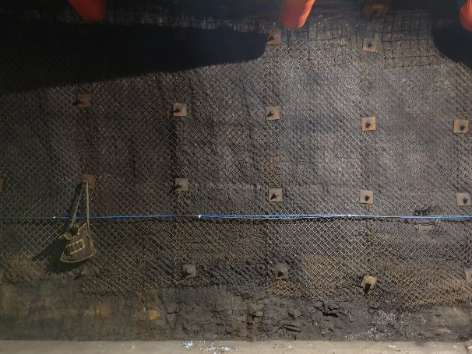
(a) Tunnel support with reasonable preload | (b) Tunnel sidewall support with reasonable preload
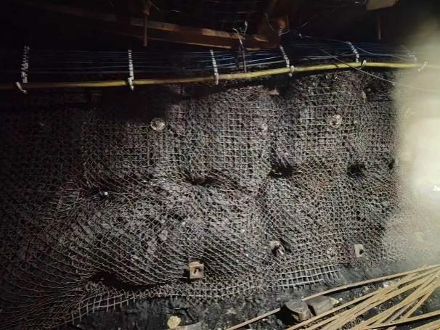 | 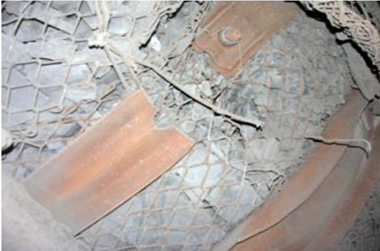
(c) Support site with bolt indentation | (d) Site with poor support due to steel strap fracture
Figure 2. Field photographs of tunnel support with different rock bolt preloads
Please use the experimental and field measurement data provided in the Attachment to solve the following problems:
Problem 1: Under standard experimental conditions with uniform material and smooth interfaces, the pre-tightening torque T (unit: N·m) and preload P (unit: kN) of the rock bolt exhibit a significant linear correlation. In engineering, the formula T=K⋅P⋅d is commonly used to describe this relationship, where d is the bolt diameter (unit: mm) and K is the torque coefficient. However, field measurements have revealed that the relationship between pre-tightening torque and preload is not consistently linear throughout the entire process: during the initial loading stage, due to thread clearance, washer deformation, and contact surface compaction processes, the data exhibit considerable dispersion and the relationship displays nonlinear characteristics; only after the pre-tightening torque exceeds a certain critical value does the system enter a stable working state, at which point the relationship between pre-tightening torque and preload becomes significantly linear. Please complete the following tasks.
Problem 1.1. Using the data provided in Table 1 of the Attachment, establish a mathematical model for the relationship between pre-tightening torque and preload, and determine the torque coefficient K for bolts of different diameters.
Problem 1.2. Using the field measurement data for 20 mm diameter bolts provided in Tables 2 and 3 of the Attachment, determine the critical pre-tightening torque.

Problem 2: As shown in Figure 1, the steel strap is a composite component of the rock bolt support system. Its function is to distribute the concentrated pressure of individual rock bolts over a larger area of the surrounding rock surface, effectively preventing localized indentation of the surrounding rock. When the surrounding rock is relatively soft, it is difficult to avoid indentation using only the bearing plate; in such cases, steel straps must be added to distribute the pressure. In actual mining engineering, the application of preload must balance effectiveness and safety — if the preload is too low, the bolt cannot provide effective support; if the preload is too high, it may cause bolt yielding, anchorage failure, or bearing plate indentation into the coal body (as shown in Figure 2(c)). Please solve the following problems.
Problem 2.1. Based on the physical model and engineering constraints described in Appendix 2, establish a general parameterized model for the maximum allowable pre-tightening torque T_{max} under given geological and support parameters, and further determine the necessity of using steel straps.
Problem 2.2. Using the parameters provided in Table 4 of the Attachment, combined with the mathematical model constructed in Problem 2.1, calculate T_{max} for Working Condition A and Working Condition B, and determine whether steel straps must be added.

Problem 3: In on-site coal mine construction, due to objective factors such as coal-rock fragmentation and irregular borehole walls, there is an unavoidable eccentricity e (unit: mm) between the bolt axis and the normal to the surrounding rock surface. When the nut is tightened to apply the pre-tightening torque T, the preload P generates an additional bending moment M at the bolt thread section through the eccentricity e. At this point, the bolt thread section is simultaneously subjected to the combined action of multiple stresses, which may cause the bolt to fracture at the thread root. The relevant mechanical formulas and parameters are detailed in Appendix 3. Please complete the following tasks.
Problem 3.1. Based on the mechanical model in Appendix 3, establish a mathematical model for the relationship between the maximum allowable pre-tightening torque T_{max} and the eccentricity e under eccentric loading conditions. Since this mechanical formula is based on simplified assumptions using the nominal cross-section, analyze the applicability and limitations of the model in Appendix 3 based on fundamental mechanical principles.
Problem 3.2. Considering the eccentric loading condition together with the engineering constraints given in Appendix 2, analyze whether the presence of eccentricity e affects the validity of these constraints. Establish a revised model that comprehensively considers multiple failure modes, provide the mathematical expression for the revised maximum allowable pre-tightening torque T_{max}(e), and perform numerical verification.

Problem 4: In practical engineering, the surrounding rock properties vary significantly across different coal mines. Hard surrounding rock (e.g., limestone, Protodyakonov coefficient f ≥ 6) has high elastic modulus and strength, capable of withstanding large support forces without indentation or failure; soft surrounding rock (e.g., coal body, Protodyakonov coefficient f < 3) has low elastic modulus, and excessive support forces can easily cause the bolt to indent into the surrounding rock, leading to support failure; medium-strength surrounding rock (e.g., sandstone, 3 ≤ f < 6) lies between the two extremes. Therefore, different surrounding rock grades have distinctly different requirements for preload and load-bearing capacities. Currently, on-site bolt support construction often adopts a uniform pre-tightening torque standard, which neither fully exploits the bearing potential of hard surrounding rock nor avoids the risk of support failure in soft surrounding rock.
Please establish a mathematical model for the relationship between the optimal pre-tightening torque T_{opt} and the Protodyakonov coefficient f that achieves favorable support performance without triggering any failure constraints. Analyze the “dominant failure mode” that causes the bolt support system to fail in different f value intervals (e.g., soft rock, medium rock, hard rock) — that is, under various surrounding rock conditions, which constraint first reaches the limit for the maximum allowable pre-tightening torque. Verify the effectiveness and reliability of the model.

Appendix 1: Terminology and Symbol Definitions
Term/Symbol | Name | Description
Steel strap | — | Strip-shaped metal member laid along the tunnel direction, used to distribute bearing plate pressure and prevent localized indentation of surrounding rock
Bearing plate | — | Load-bearing plate installed between the nut and surrounding rock, transmitting preload to the surrounding rock surface
Self-aligning washer | — | Washer with spherical or curved surface structure that can automatically compensate for bolt installation angle deviation
T | Pre-tightening torque | Tightening torque applied to the nut shown in Figure 1 during construction, unit: N·m
P | Preload / Bearing force | Axial tensile force along the bolt body generated by pre-tightening torque through thread transmission, unit: kN
K | Torque coefficient | Proportional coefficient of the conversion relationship between pre-tightening torque and preload
d | Nominal diameter | Nominal outer diameter of the bolt body, unit: mm
$$D_{hole}$$ | Borehole diameter | Diameter of the bolt installation hole, unit: mm
$$d_{e}$$ | Thread effective diameter | Equivalent diameter of the thread stress cross-section, approximately $d_{e}≈0.85d$
$$L_{s}$$ | Effective anchorage length | Length of the actual bonding section between anchoring agent and surrounding rock, unit: mm
$$σ_{s}$$ | Yield strength | Stress at which the bolt body material begins to undergo plastic deformation, unit: MPa
[σ] | Allowable stress | Maximum stress the material is permitted to withstand, $\left[σ\right]=σ_{s}/n$, where n is the safety factor
n | Safety factor | Reduction factor introduced to ensure structural safety
$$K_{s}$$ | Thread effective torque coefficient | Proportion of the applied torque that is effectively borne by the thread section
τ | Shear strength | Capacity of the anchoring agent–surrounding rock interface to resist shear failure, unit: MPa
$$F_{bond}$$ | Ultimate bonding force | Maximum axial force the anchorage system can withstand before interfacial shear failure
E | Elastic modulus of surrounding rock | Capacity of surrounding rock to resist elastic deformation, unit: GPa or MPa
ν | Poisson’s ratio | Ratio of transverse strain to axial strain of the material, dimensionless
h₀ | Influence depth of surrounding rock load | Depth to which the bearing plate exerts external force on the surrounding rock, unit: mm
$$δ$$ | Indentation depth of surrounding rock | Depth to which the bearing plate indents into the surrounding rock surface, unit: mm
b | Bearing plate side length | Equivalent side length of the bearing plate load-bearing surface, unit: mm
e | Eccentricity | Distance between the bolt axis and the normal to the surrounding rock surface, unit: mm
$$σ_{t}$$ | Axial tensile stress | Normal stress caused by the axial preload P
$$σ_{b}$$ | Bending stress | Normal stress caused by the additional bending moment due to eccentricity
$$τ$$ | Torsional shear stress | Shear stress generated in the thread section by the construction tightening torque
Von Mises equivalent stress | — | Equivalent yield criterion that combines normal and shear stresses, used to determine whether the material enters the plastic state
f | Protodyakonov coefficient | Empirical index characterizing rock firmness; larger values indicate harder rock, uniaxial compressive strength (MPa) / 10
$$W_{b}$$ | Section modulus in bending | Geometric parameter of cross-section resistance to bending; for circular cross-section, $W_{b}=\frac{πd^{3}}{32}$
$$W_{t}$$ | Section modulus in torsion | Geometric parameter of cross-section resistance to torsion; for circular cross-section, $W_{t}=\frac{πd^{3}}{16}$
$$A_{e}$$ | Thread effective cross-sectional area | Equivalent area of the thread stress cross-section, $A_{e}=\frac{πd_{e}^{2}}{4}$

Appendix 2: Physical Model and Engineering Constraints for Problem 2
(1) Bolt strength limit: The preload P must not exceed the yield load $P_{yield}$ of the bolt body.
(2) Anchorage system limit: The preload P must not exceed the ultimate bonding force $F_{bond}$ between the anchoring agent and surrounding rock.
$$F_{bond}=π⋅D_{hole}⋅L_{bond}⋅τ⋅{10}^{−3} \left(\text{kN}\right)$$
Where $D_{hole}$ is the borehole diameter (mm), $L_{bond}$ is the effective anchorage length (mm), and $τ$ is the shear strength at the surrounding rock-anchoring agent interface (MPa). Furthermore, it is assumed that the shear strength $τ$ (unit: MPa) and the elastic modulus of the surrounding rock E (unit: GPa) satisfy the following relationship:
$$τ=0.25⋅E+1.0$$
(3) Surrounding rock indentation limit: When only the bearing plate is used, if the indentation depth $δ$ of the bearing plate into the surrounding rock exceeds the allowable indentation depth $δ_{max}$, it is determined that steel straps must be added under the current working condition to distribute the pressure. The indentation depth $δ$ can be estimated using the Winkler elastic foundation model:
$$δ=\frac{P⋅\left(1−ν^{2}\right){⋅h}_{0}}{E⋅b^{2}}$$
where E is the elastic modulus of the surrounding rock (GPa), $ν$ is Poisson’s ratio, $b$ is the bearing plate side length (mm), $h_{0}$ is the influence depth of the surrounding rock load (mm), and P is the preload.

Appendix 3: Mechanical Formulas and Parameters for Problem 3
The bolt thread section is simultaneously subjected to the combined action of the following three stresses:
（1）Axial tensile stress $σ_{t}$: Caused by the preload P.
$$σ_{t}=\frac{P}{A_{e}}=\frac{T}{K⋅d⋅A_{e}}$$
（2）Bending stress $σ_{b}$: Caused by the additional bending moment $M=P⋅e$ generated by the eccentricity e.
$$σ_{b}=\frac{M}{W_{b}}=\frac{P⋅e}{W_{b}}=\frac{T⋅e}{K⋅d⋅W_{b}}$$
（3）Torsional shear stress $τ$: Caused by the effective thread torque $T_{s}=K_{s}⋅T$ during the construction tightening process:
$$τ=\frac{K_{s}⋅T}{W_{t}}$$
The superposition of these three stresses may cause the bolt to fracture at the thread root. In engineering, the Von Mises equivalent stress criterion is commonly used for assessment, requiring that the equivalent stress $σ_{eq}$ not exceed the allowable stress $\left[σ\right]$ of the material:
$$σ_{eq}=\sqrt{{\left(σ_{t}+σ_{b}\right)}^{2}+3τ_{ }^{2}}≤\left[σ\right]$$
In the above formulas, all stresses are calculated using the nominal geometric parameters of the effective thread cross-section. In practical engineering, the abrupt change in cross-section at the thread root leads to stress concentration, and the actual maximum stress may be higher than the nominal stress value.
The geometric parameters of the thread effective cross-section (effective cross-sectional area $A_{e}$, section modulus in bending $W_{b}$, section modulus in torsion $W_{t}$) can be calculated from the thread effective diameter $d_{e}$ using circular cross-section formulas (reference: $d_{e}=0.85d$).
For ease of calculation, typical material and construction parameters may be selected from the following table:
No. | Parameter | Symbol | Value | Unit
1 | Bolt yield strength | $$σ_{s}$$ | 500 | MPa
2 | Torque coefficient | $$K$$ | 0.18 | —
3 | Thread effective torque coefficient | $$K_{s}$$ | 0.09 | —
4 | Nominal diameter | $$d$$ | 20 | mm
Note: For this problem, take the safety factor n=1.0, i.e., allowable stress $\left[σ\right]=σ_{s}=500 MPa$.

